PERSONAL INFORMATION | Mite Shterjov
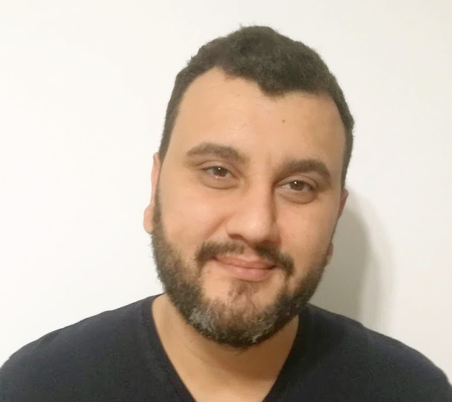 |   Skopje, N. Macedonia
 |  ++389 71 673 086

mite.shterjov@gmail.com
github: https://github.com/miteShterjov/
linkedin: https://miteshterjov.itch.io/
itch.io: https://mk.linkedin.com/in/mite-shterjov-67397b321

Skype: miteshterjov Viber/Whatsup: 071673086
 | Date of birth 04/10/1985 | Nationality Macedonian, Citizen of N. Macedonia

WORK EXPERIENCE

09.2025 – present | Freelance Unity Programmer
09.2025 – present | Freelance, Self-Emplyed
09.2025 – present | Actively building a portfolio of systems-driven game projects. Focused on implementing clean C# architecture, finite state machines, and procedural workflows in Unity to create modular, scalable gameplay mechanics.
 | Business or sector Real Estate

10.2019 - 08.2025 | Content Editor & Digital Marketing Officer
10.2019 - 08.2025 | Aliance Real Estate Malta
10.2019 - 08.2025 | Draft and edit engaging content for social media marketing, ensuring brand consistency and audience awareness. Manage content strategy across multiple platforms, optimizing for reach and engagement.
 | Business or sector Real Estate

11.2014 - 08.2019 | Information Technology Officer
11.2014 - 08.2019 | Erak Grup DOO | www.karacibalkan.com | www.gnezdo.mk | www.manoragroup.com
11.2014 - 08.2019 | - Web development, design and maintenance of company websites like: www.karacibalkan.com, www.gnezdo.mk, www.skopjeshuttle.com and is currently www.https://wtransporter.com, www.wtouristic.com. Technologies used for the projects: Wordpress and OctoberCMS (build with Laravel Framework).  - Marketing on Facebook, management of our Facebook pages (Karaci Tours, Gnezdo Kitchen Bar and Manora Shuttle Skopje) including promotions, posts, image editing and advertisement.  - Design of company resources like envelopes, memos, business cards, vehicle branding, Skopje Shuttle bus, etc.  - General IT support.
11.2014 - 08.2019 | Business or sector Tourism, Transport and Service Industry

10.2014 – 04.2017 | Information Technology Officer
10.2014 – 04.2017 | MTarget/MStore Skopje, Macedonia | www.mtarget.info
10.2014 – 04.2017 | - Web development, design and maintenance of WordPress and PrestaShop based e-commerce and e-marketing sites who sold various products.  - Marketing on Social Media: Facebook, Instagram, EasyAds, Goodle Ads. Design of pictures and HTML5 banner ads.  - General IT support.
10.2014 – 04.2017 | Business or sector Retail, Marketing, Advertisement

03.2014 – 09.2014 | Technical Support – First level
03.2014 – 09.2014 | Stopanska Banka AD Skopje | www.stb.com.mk
03.2014 – 09.2014 | - Troubleshooting software relevant for the day-to-day working process.  - Creating and maintaining a printer server and network.  - Maintaining, creating and deleting Active Directory Users.  - General IT support.
03.2014 – 09.2014 | Business or sector Banking and Finance

06.2011 – 10.2013 | Technical Support
06.2011 – 10.2013 | Sky Shped DOO Skopje | www.skyshped.mk
06.2011 – 10.2013 | - Troubleshooting software relevant for the day-to-day working process.  - Creating and maintaining a printer server and network.  - Maintaining/replacing hardware components .
06.2011 – 10.2013 | Business or sector Transport and Logistics

03.2010 – 12.2010 | Journalist
03.2010 – 12.2010 | NIP Nova Makedonija Skopje | www.novamkedonija.com.mk
03.2010 – 12.2010 | Writing short and medium stories about current events for the Chronical Section of the Paper.
03.2010 – 12.2010 | Business or sector News and Journalism

10.2009 – 02.2010 | Journalist
10.2009 – 02.2010 | Kapital KMG DOO Skopje | www.kapital.com.mk
10.2009 – 02.2010 | Writing stories about current events for the Politics and Economics Section of the Daily Paper Kapital.
10.2009 – 02.2010 | Business or sector News and Journalism

05.2009 – 10.2009 | Project Officer
05.2009 – 10.2009 | NGO Macedonian Humanitarian Centre Skopje
05.2009 – 10.2009 | Managing and implementing various projects funded by the Macedonian Australian Orthodox Community aiming to help socially and economically vulnerable groups in the regions of Bitola, Prilep and others in south west Macedonia.
05.2009 – 10.2009 | Business or sector Non-profit and Activism

10.2008 – 02.2009 | Administrative Assistant
10.2008 – 02.2009 | DeSo Consulting Skopje | www.deso.mk
10.2008 – 02.2009 | Day to day administrative and technical assistance.
10.2008 – 02.2009 | Business or sector Consulting

EDUCATION AND TRAINING

2010 – present | Information Technology Engineer
2010 – present | Faculty for computer science and engineering FINKI at UKIM  *paused in 2014 at second year of studies from total of 3
2004 – 2008 | Batchelor in Political Science
2004 – 2008 | Faculty of Law “Iustinianus Primus” Skopje at UKIM
2004 – 2008 | The field always requires continues upgrade of skills and knowledge so I often use educational courses online like: Udemy, GameDev.tv, Laracast, KnpUnivirsety, Skillshare etc.
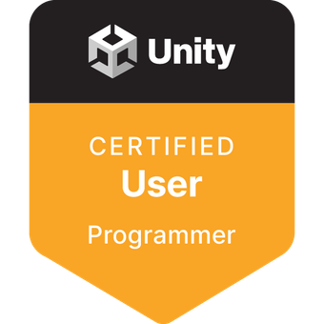   | Unity Certified User: Programmer  Unity - Issued May 2024  Unity Junior Programmer  Unity - Issued Apr 2024

PERSONAL SKILLS

Mother tongue(s) | Aromanian (Vlashki), Macedonian
Other language(s) | UNDERSTANDING |  | SPEAKING |  | WRITING
Other language(s) | Listening | Reading | Spoken interaction | Spoken production
English | C2 | C2 | C2 | C2 | C2
German | A1.2 | A1.2 | A1.2 | A1.2 | A1.2
Self-evaluation.
Levels: A1/A2: Basic user - B1/B2: Independent user - C1/C2 Proficient user
Common European Framework of Reference for Languages

DIGITAL COMPETANCE | SELF-ASSESSMENT
 | Proficient user | Proficient user | Proficient user | Proficient user | Proficient user
Levels: Basic user - Independent user - Proficient user
Digital competences - Self-assessment grid
 | Self-Assessment
List of IT related skills used so far or in the process of learning:

Programming: C# and .NET, Unity Engine, OOP (Object-Oriented Programming), Design Patterns

Technical Highlights: Gameplay Systems, State Machines, Enemy AI, UI Systems, Save Systems, Inventory Systems

Tools: Unity, JetBrains Rider, GitHub, Blender, Aseprite

ADDENDUM
Driving licence | Category B – since 2009 active driver

Other Freelance projects | Web design and development of various freelance projects:  - www.enterierstudio.mk (used OctoberCMS)  - www.brzapratka.com (used WordPress, Laravel)  - www.korektnafirma.net (used WordPress, Laravel)  - www.disleksija.com.mk (used Ionic, CodeIgniter based CMS)  - www.toilstructure.com.mk (also Corporate Brand for Toil Structure DOO: logo, office supplies, business cards, posters) (used Laravel, OctoberCMS)

